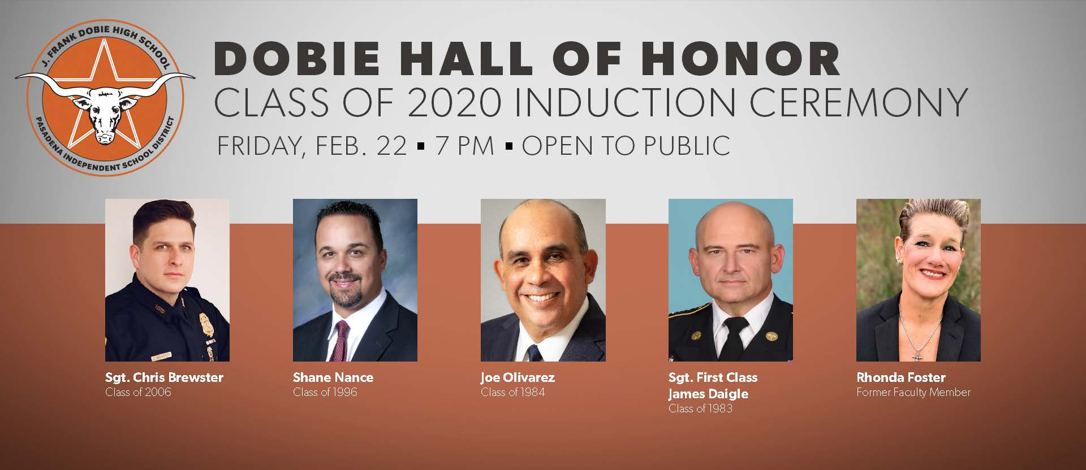
Dobie High School announces 2020 Hall of Honor inductees
Story Posted here: https://www1.pasadenaisd.org/cms/One.aspx?portalId=80772&pageId=36967504
Now in its eighth year, Dobie High School will host their annual Hall of Honor induction ceremony, February 21, to recognize five individuals, including four graduates and a faculty member. The honorees include Sgt. Chris Brewster, Class of 2006; Shane Nance, Class of 1996; Joe Olivarez, Class of 1984; Sgt. First Class James Daigle, Class of 1983; and former faculty member Rhonda Foster.
The Dobie High School Hall of Honor recognizes graduates who have made significant contributions in the community and serve as role models to students. This recognition is the highest honor bestowed to Longhorn alumni or former faculty members.
The induction ceremony will start at 7 p.m., followed by a reception.
The honorees are:
Christopher “Chris” Brewster – Class of 2006
A devoted husband, loving son, brother, uncle, and friend, Houston Police Officer, Christopher Charles Lewis Brewster was known to his fellow Longhorns and colleagues as an eclectic individual with a wonderful sense of humor. While in high school, he took all honors math classes and also participated in the Dobie marching band. Considered as the class clown, Brewster received an original "Most Memorable Band Student" award.
After graduating from Dobie High School in 2006, he attended Texas A&M University-Commerce, where he obtained a bachelor’s degree in Organizational Leadership. Brewster graduated from the Houston Police Department Academy in November 2010.
Brewster was assigned to Southeast Patrol and advanced later on to the elite Gang Division, SWAT and Major Offenders Division. In February 2019, he was promoted to Sergeant and served Eastside Patrol where he quickly became known as the "favorite Sergeant" by his officers. Always wanting to learn new things, Brewster was in the process of completing his master’s degree. A nine-year police force veteran, Brewster’s wife, Bethany said, “Heaven gained a hero,” on December 7, 2019, after he was fatally shot, while responding to a domestic violence call in Magnolia Park. He leaves behind his wife, parents Lewis and Dobie alumnus Cynthia (Rentz) Brewster and three sisters: Renee Trager, Ashley Barrera, and Lindsay Brewster.
Shane Nance, Class of 1996
As resumes go, Shane Nance has knocked it out the park. Nance was a member of the U.S. National baseball team from 1998 to 1999 and 2002, earning a silver medal in the 2001 championship.
Before heading to the pros, Nance played baseball for the University of Houston while working toward a bachelor’s degree in marketing.
After obtaining his bachelor’s degree in 2000, he was signed to the Los Angeles Dodgers in the 11th round of the MLB draft for a two-year stint, ending in 2002. Nance made his big debut on August 24, 2002 when he signed as a relief pitcher for the Milwaukee Brewers, from 2002-2003. He went on to play for the Arizona Diamondbacks from 2003-2005 and finally, the Kansas City Royals.
After five years playing for the pros, Nance hung up his baseball cap and pursued a career in management with MedInc of Texas from 2006-2008.
He went on to become the athletic director, while teaching baseball, along with government and economics at Brazosport Christian School, from 2008-2010. Nance left the education field to return to management in indoor and outside sales.
He currently serves as regional manager of Stryker Ent., where he has earned multiple awards including Regional Manager for 2017, the President’s award each year from 2014-2016, the Crushed it Elite award for 2014-2016, while also achieving above quote sales in 16 out of 16 quarters. Nance has continued to serve this role since 2012. Nance resides in Pearland and is a member of New Hope Church.
Joe M. Olivarez, Class of 1984
Joe Olivarez Jr. has been in the investigative and security business for over 30 years, protecting the interests of the U.S. government and multi-billion dollar corporations across the globe. Olivarez spent his first 10 years in government and government defense as a security analyst with General Dynamics and as a special agent with the National Aeronautics and Space Administration (NASA) Johnson Space Center.
From 1997-2002, he served as the Vice President of Investigations of an International Security Firm. The company specialized in assisting Fortune 200 Corporations with solving and mitigating complex security and investigative challenges affecting their organizations.
From 2002-2013, he served multiple roles leading to vice president, enterprise security and crisis management of the Western Hemisphere at Baker Hughes Inc., an oilfield services leader with over 65,000 employees operating in 80 countries. In 2012, the BHI Enterprise Security & Crisis Management Team was recognized as Security 500's best program within the oil and gas industry. In 2013, Olivarez was hired as the first Global Security Leader for Jacobs, a world premiere design, engineering, construction and technical services firm delivering end-to-end innovative solutions, in its 70-year history.
After 30-plus years as a security, resilience and investigative professional, Olivarez has enabled global businesses to navigate the risks of new country entry strategies, operate in high risk and emerging markets, assist businesses leaders to make informed decisions in merger and acquisition activities, solve, prosecute and recover millions of dollars from embezzled funds or theft of intellectual property and return businesses to normal operations after natural disasters or terrorist events.
Olivarez received a Bachelor of Arts Degree in Criminal Justice with an emphasis in Legal Research from Stephen F. Austin State University in 1988 and earned a Master’s Degree in Business Administration from the University of Houston’s Executive Management Program in 1998.
Olivarez has successfully completed leadership programs at the Thunderbird School of Global Management, Yale Executive School of Management and is a graduate of the Federal Bureau of Investigation Domestic Security Executive Academy. He is a member of ASIS International (2020 International Board Member), ASIS Chief Security Officer Center (past chair), International Security Management Association, the U.S. State Department Overseas Advisory Security Council and FBI Domestic Security Alliance Council. In 2018, Olivarez was selected as the International SOS Ambassador Duty of Care Award Winner.
Sergeant First Class James Daigle, Class of 1983
Sergeant First Class James Daigle is a war hero. He enlisted in the Army in 2004 after his son, Alan Daigle, a U.S. Marine and Dobie graduate, was injured in Iraq. SFC Daigle has been awarded two Purple Hearts for wounds received during combat in Afghanistan. President George W. Bush honored Daigle with a pinning ceremony of one of his Purple Heart medals in Dallas. He has also obtained the following awards:
- a Bronze Star medal with “V” device for valor;
- the Legion of Merit;
- two Meritorious Service medals;
- four Army Commendation medals;
- two Army Achievement medals;
- the Combat Medical Badge;
- Air Assault Wings;
- both Gold and Silver Spurs for service in the U.S. Cavalry;
- the National Defense medal;
- both Global War on Terrorism Service and Expeditionary medals;
- NATO Deployment medal -- the Presidential Unit citation;
- Valorous Unit citation;
- Navy Unit Commendation;
- Among others.
SFC Daigle and his son are one of only a few father-son teams with Purple Heart medals from being wounded in the same conflict. His goal while serving on the frontlines was to make sure everyone did their duty and made it home alive. SFC Daigle was successful at accomplishing that goal with his team of medics. In recognition of his valor, bravery and heroism, he was honored by the President of the United States, in addition to becoming a Kentucky Colonel by the State of Kentucky, a Jack Daniels Squire by the State of Tennessee and an Admiral in the Texas Navy by Texas Governor, Rick Perry. He has been designated a “Hometown Hero” by the Houston Texans, Dallas Cowboys, Houston Astros and Texas Rangers, throwing out the first pitch at the Astros and Ranger games. SFC Daigle has participated in more than 75 combat missions. After serving for 15 years and deploying to Afghanistan, Korea and Africa in the Military, he retired in the fall of 2019.
Rhonda Foster, Faculty Member from 1983-2005
With more than 20 years under her belt, Rhonda Foster has seen her share of wins. It all started when she joined Dobie High School in 1983. During her first semester at Dobie, Foster taught P.E. and then health the following semester. In November 1983, under the helm of then coach Joan Walker, Foster coached track as an assistant. She also served as the head coach of the girls’ cross-country team until 1992. One year into her coaching career and Foster coached the girls’ cross-country team to state. From ’87 -‘94, Foster coached the girls soccer and cross-country teams. In 1992, Foster switched teams with then coach Phil Reidel to coach boys’ cross-country, while Reidel coached girls’ cross-country. She continued to teach boys- cross-country for 14 years.
Foster was certainly the coach of all trades. For the 1994-1995 school year, she decided to coach girls’ softball until her departure in 2005. Her excellent coaching ability led to many successes for her students and teams. Under her leadership, Dobie alum Ras Bowman won the state title in the 800-meter run in 1998. Another Longhorn alum, Scott Lengefeld went to state twice as an individual in cross-country in 1995 and in 1996. The Dobie girls’ softball team, under her leadership, knocked it out the park in 1995 and won the state championship in softball UIL, carrying with them an undefeated title of 33-0 all the way to state. Out of the nine starters on the team, five signed to play division 1 college softball.
In 1997, with a losing record of 11-13, the odds of going to state seemed unlikely for the Dobie girls’ softball team. They made the cut to the playoffs anyway because during the late 90s, UIL took the top three teams to the state championship game, with Dobie being one of them. After advancing to the playoffs, the Longhorns flipped their losing streak to a six straight winning streak to capture the state title in 1997. The record-breaking 1997 Dobie softball team is the only third place finisher to win a state championship title in Pasadena ISD.
It’s safe to say that Foster fostered a competitive spirit in students at Dobie like no other. In 2001, she coached Brian McKinstry to a 13-straight undefeated winning streak that pushed him across the finish line in the individual state cross-country championship for a title win.
In 2005, Foster hung up her coaching whistle and moved to Round Rock to teach P.E. at Union Hill Elementary School until her retirement in 2016.

